Subnetting (Troubleshooting 2)

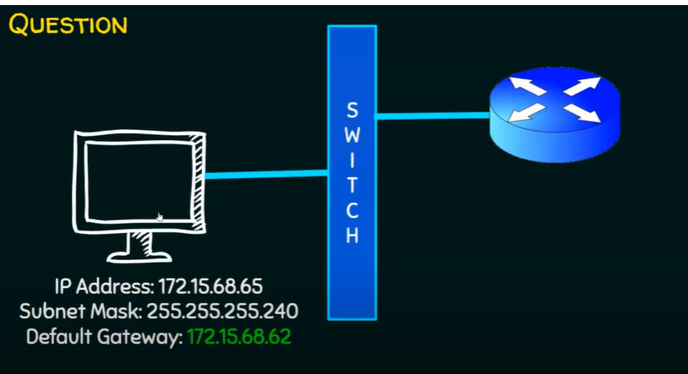

Computer cannot send ping to the router. WHY?

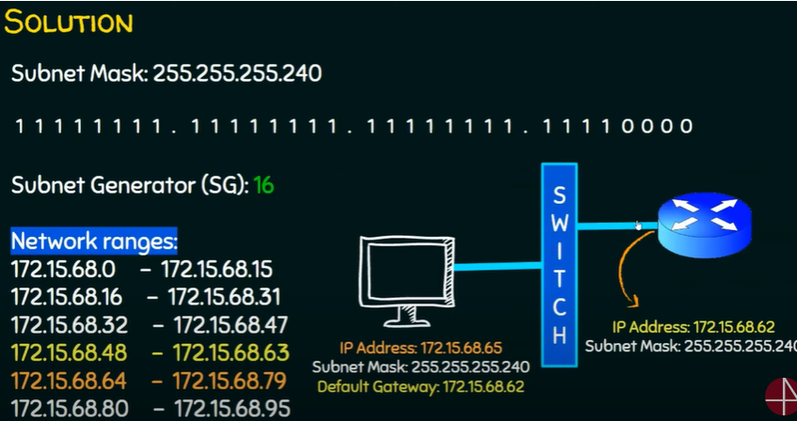

Default gateway and the host is not on the same subnet.

Solution:

1. Change the Host IP address or
2. Change the default gateway address

So that they are in the same network.